**Flutter Project Setup Instruction (Ubuntu)**

**For**

**Plant Diagnosis System**

# **System Requirements**

To install and run Flutter, your development environment must meet these minimum requirements:

* **Operating Systems**: Linux (64-bit)
* **Disk Space**: 600 MB (does not include disk space for IDE/tools).
* **Tools**: Flutter depends on these command-line tools being available in your environment.
  + bash
  + curl
  + file
  + git 2.x
  + mkdir
  + rm
  + unzip
  + which
  + xz-utils
  + zip
* **Shared libraries**: Flutter test command depends on this library being available in your environment.
  + libGLU.so.1 - provided by mesa packages such as libglu1-mesa on Ubuntu/Debian

**Download Flutter SDK**

* + 1. Download the following installation bundle to get the latest stable release of the Flutter SDK:

<https://flutter.dev/docs/get-started/install/linux>

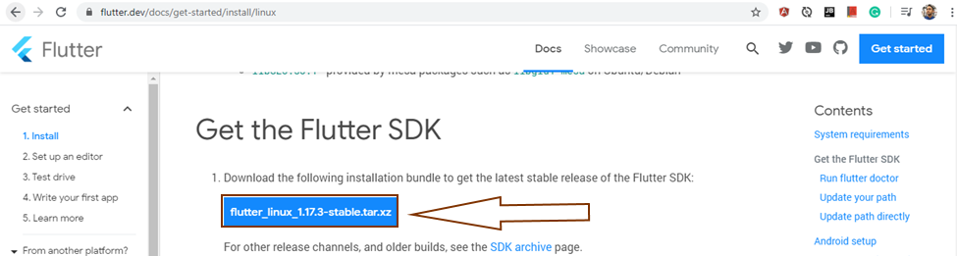

* + 1. Extract the file in the desired location, for example:

Create new folder in home directory “development” and open terminal then type:

$ cd ~/development

To go to the development directory

Now use below command for extracting the downloaded SDK.

$ tar xf ~/Downloads/flutter\_linux\_1.17.3-stable.tar.xz

And go to development=>flutter=> 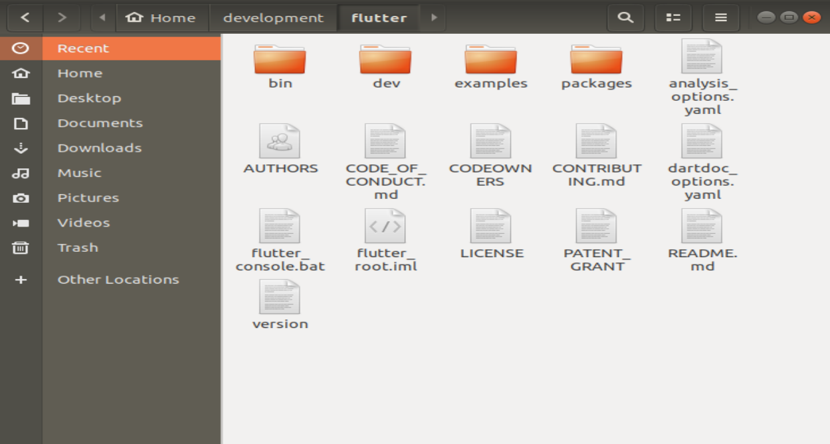 you find those files and folder

# **Update Path:**

1. Determine the directory where you placed the Flutter SDK. You need this in Step 3.
2. to edit $HOME/.bashrc. use this command: $ gedit ~/.bashrc

it will open the .bashrc file.

1. Add the following line and change [PATH\_TO\_FLUTTER\_GIT\_DIRECTORY] to be the path where you cloned Flutter’s git repo at the end of the .bashrc file:

$ export PATH="$PATH:[PATH\_TO\_FLUTTER\_GIT\_DIRECTORY]/flutter/bin"

It should be like this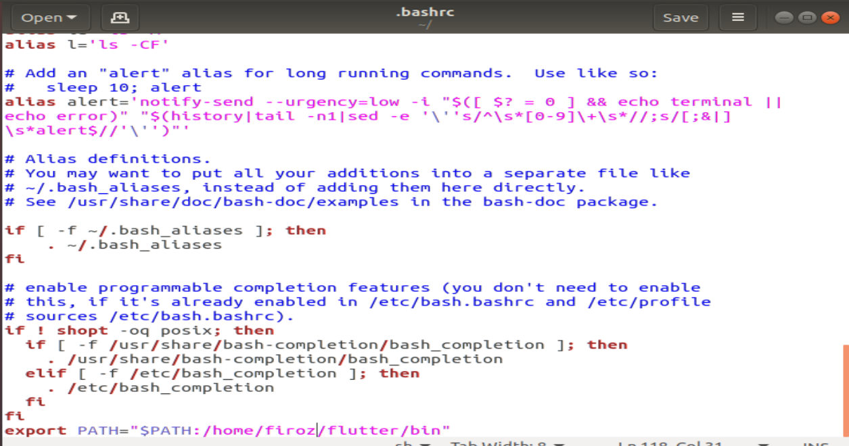

And save and close the file.

1. Run source $HOME/.<rc file> to refresh the current window, or open a new terminal window to automatically source the file.
2. Verify that the flutter/bin directory is now in your PATH by running:

$ echo $PATH

Verify that the flutter command is available by running:

$ which flutter

# **Run Flutter Doctor**

1. Run the following command to see if there are any dependencies you need to install to complete the setup (for verbose output, add the -v flag):

$ flutter doctor

If you got “Error: unable to find git in your path ” this error you will need to install git in your system using this command

$ sudo apt-get install git

1. Now flutter doctor command will work and if Android studio is already installed it will show this 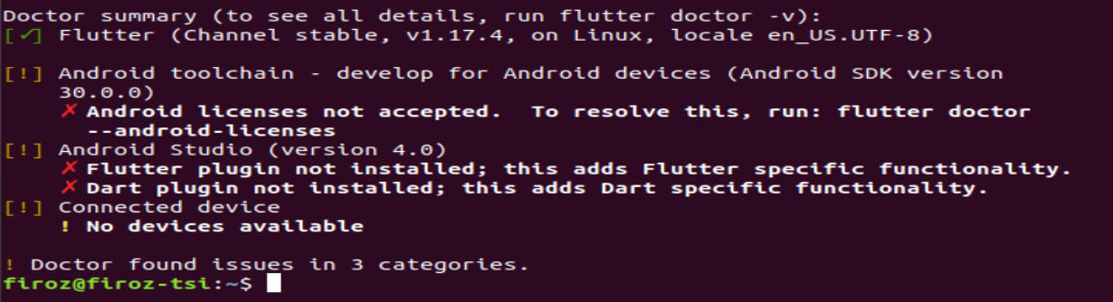

# **Android Setup: Install Android Studio**

1. Download and install from: <https://developer.android.com/studio>

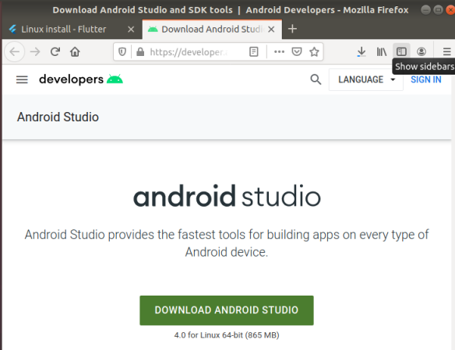

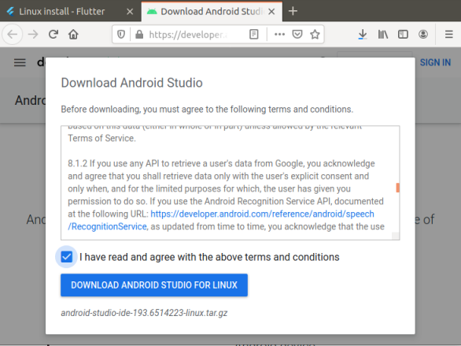

1. Extract the zip file and go to the bin directory and type: ./studio.sh



1. It will go through the ‘**Android Studio Setup Wizard**’.
2. Select Do not import settings and click Ok.

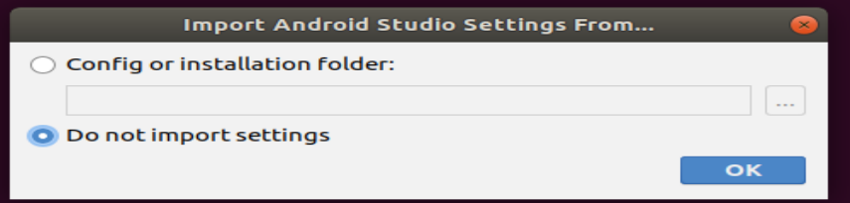

1. Procced to setup 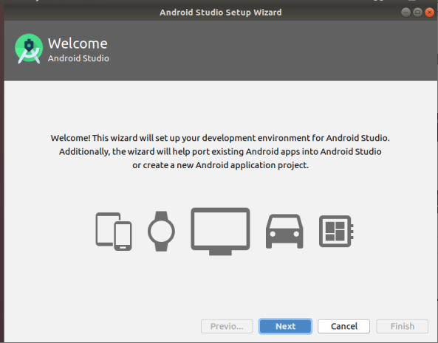
2. Select standard option 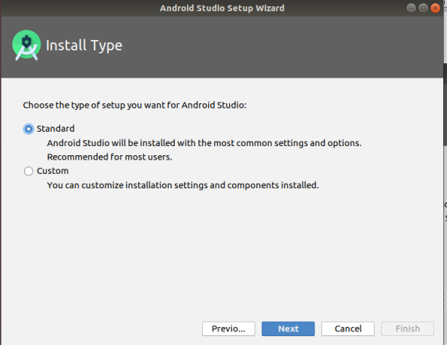
3. It will download all required files on its own to complete the setup 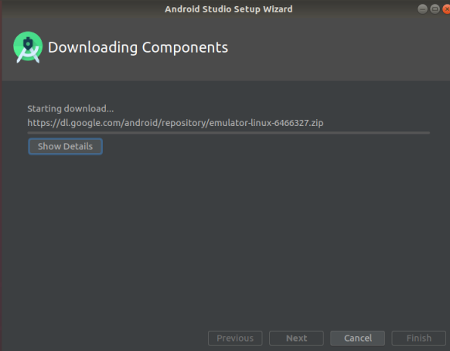
4. Click Finish to complete the Android Studio Setup 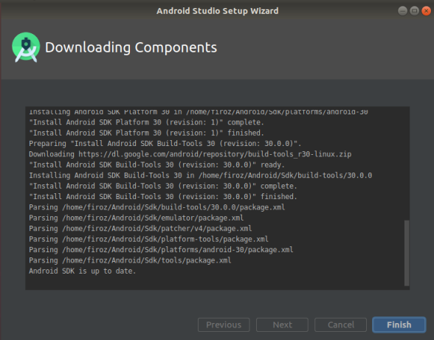
5. This installs the latest Android SDK, Android SDK Command-line Tools, and Android SDK Build-Tools, which are required by Flutter when developing for Android.
6. After open the Android studio this window will appear: 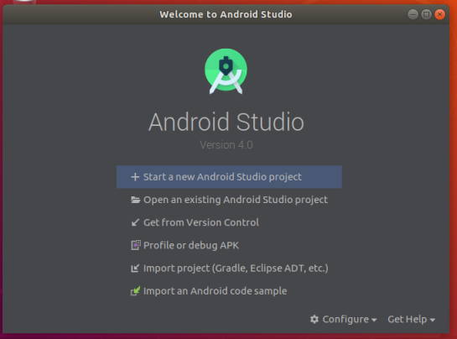

**Warning:** In Android Studio 3.6 or later, it needs to manually add the old version of the Android SDK Tools for Flutter to work. To do this:

* Open the **Android Studio SDK Manager**
* In the Android SDK tab, uncheck **Hide Obsolete Packages**
* Check **Android SDK Tools (Obsolete)**

The image below shows the appropriate settings:

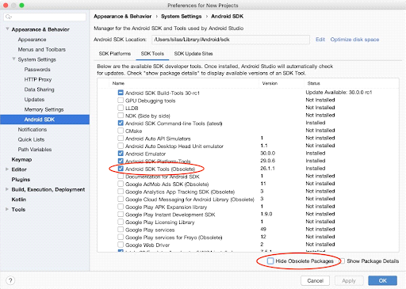

This is a [**known issue**](https://github.com/flutter/flutter/issues/51712) that will be addressed in an upcoming version of Flutter.

# **Install the Flutter and Dart plugins**

To install these:

1. Start Android Studio. 
2. Open plugin preferences (**Configure > Plugins** as of v3.6.3.0 or later). 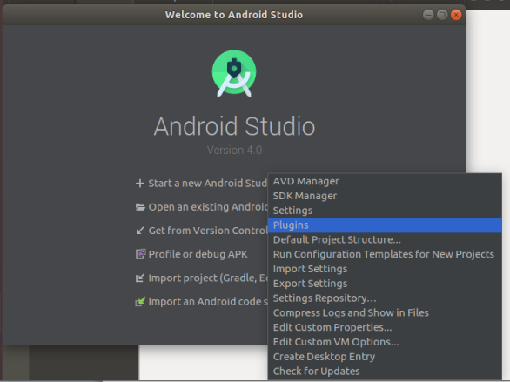
3. Search and select the Flutter plugin and click **Install**. 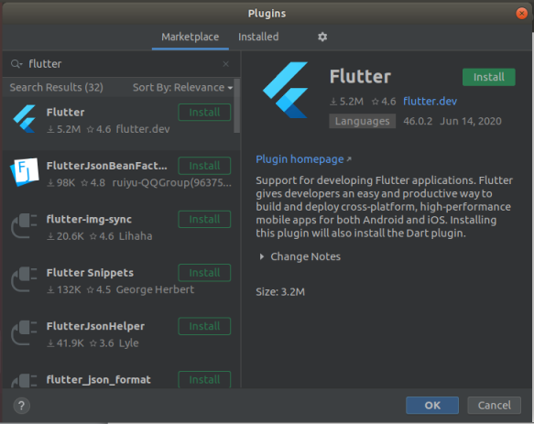
4. Click **Install** when prompted to install the Dart plugin. 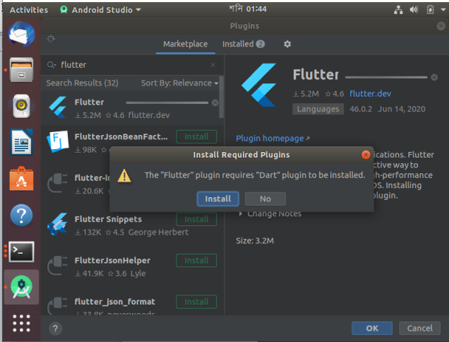
5. Click **Restart IDE** 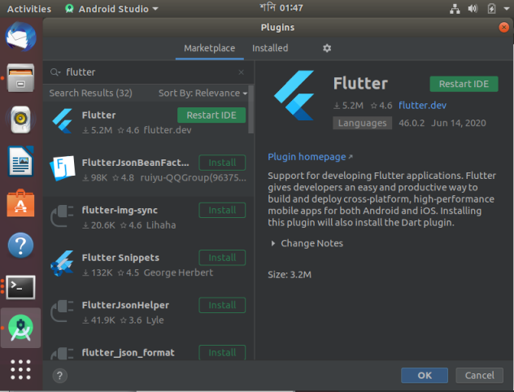
6. Android Studio will start again and you can create or import project from here. 

# **Set up Android Device:**

To run and test Flutter app on an Android device, It needs an Android device running **Android 4.1** (API level 16) or higher.

1. Enable **Developer options:**  go to **“Settings > About Phone”**

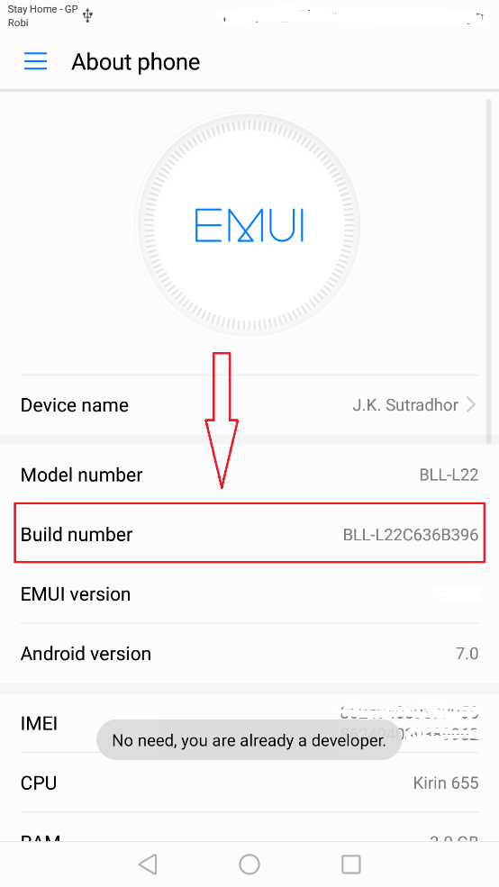

1. Tap 5-7 times continues on **‘Build Number’** (It will enable developer option for Project Run)
2. After tapping, it will show a toast **‘You are in developer mode’**.  
   If you did this already, you will get the toast **‘No need, you are already a developer’** .
3. Again, Go to “**Settings > Developer Option”**
4. Enable **USB debugging** on your device. Tap on the **‘USB debugging’** to enable it.
5. And If the alert dialogue is opened then simply click on the marked ‘OK’ button

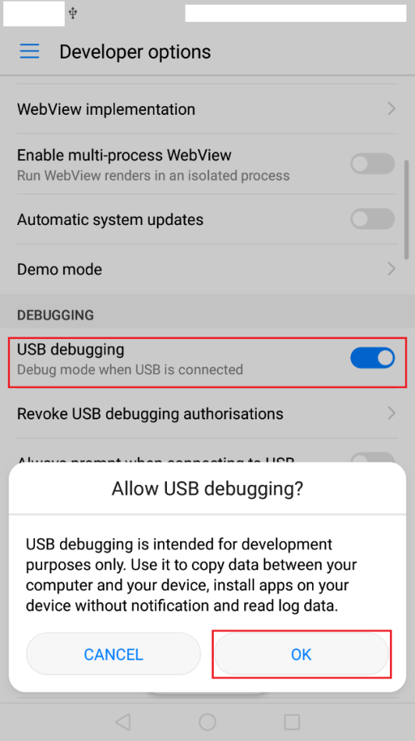

1. Using an USB cable, plug the phone into the computer. If prompted on the device, authorize the computer to access that device by click on the marked ‘OK’ button.

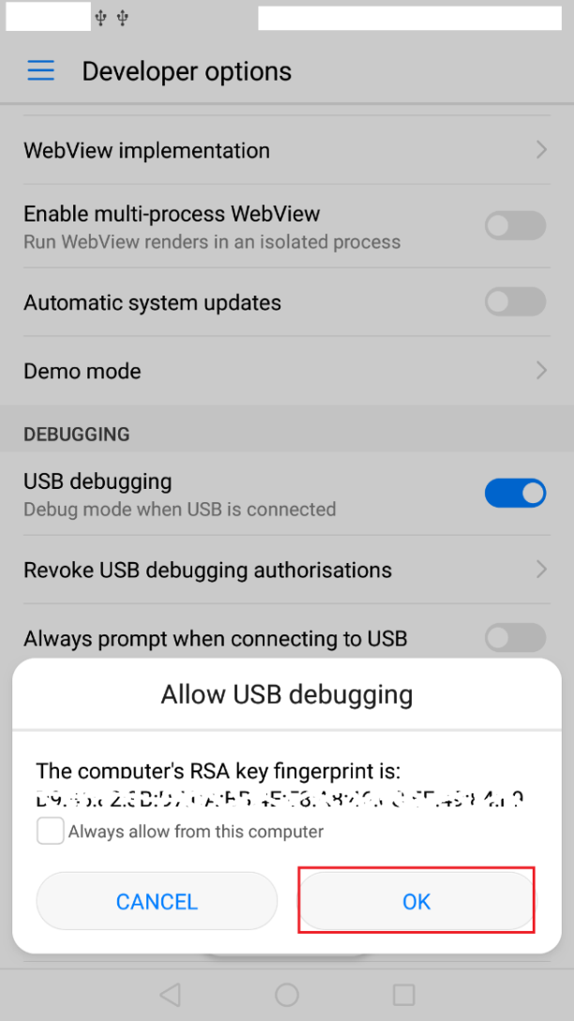

**Windows-only,** Install the[**Google USB Driver**](https://developer.android.com/studio/run/win-usb) if it fails to detect automatically. Help guide is available in- <https://developer.android.com/studio/run/win-usb>

1. In the terminal, run the **flutter devices** command to verify that Flutter recognizes the connected Android device.

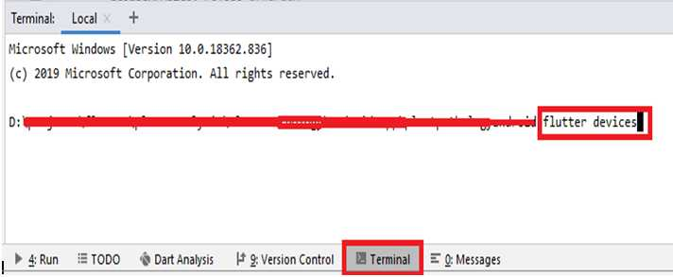

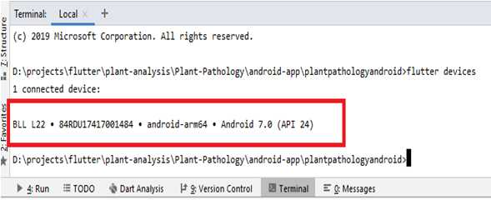

# **Set up the Android Emulator:**

To prepare to run and test Flutter app on the Android emulator, follow these steps:

* Enable [VM acceleration](https://developer.android.com/studio/run/emulator-acceleration) on your machine.

1. Start Android Emulator.
2. Click on the marked Icon as below image



1. Click on the **Create Virtual Device**

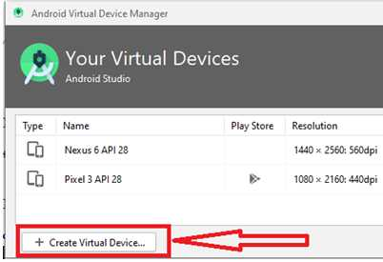

Or, Launch **Android Studio > Tools > Android > AVD Manager** and select “**Create Virtual Device”**. (The **Android** submenu is only present when inside an Android project.)

1. Choose a device definition and select **Next**.

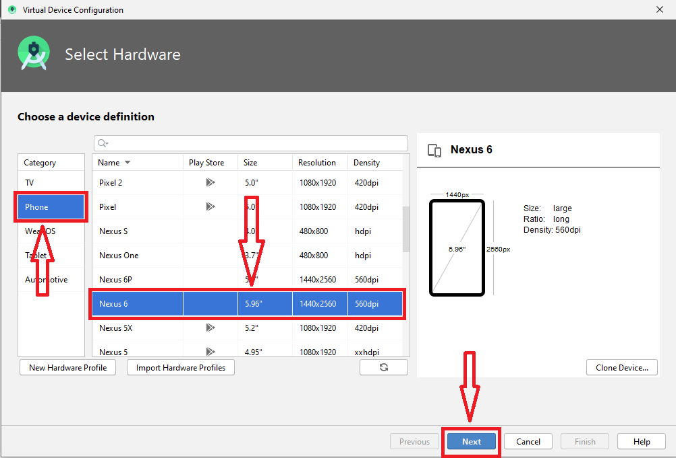

1. Select one or more system images for the Android versions, and select **Next**. An *x86* or *x86\_64* image is recommended.

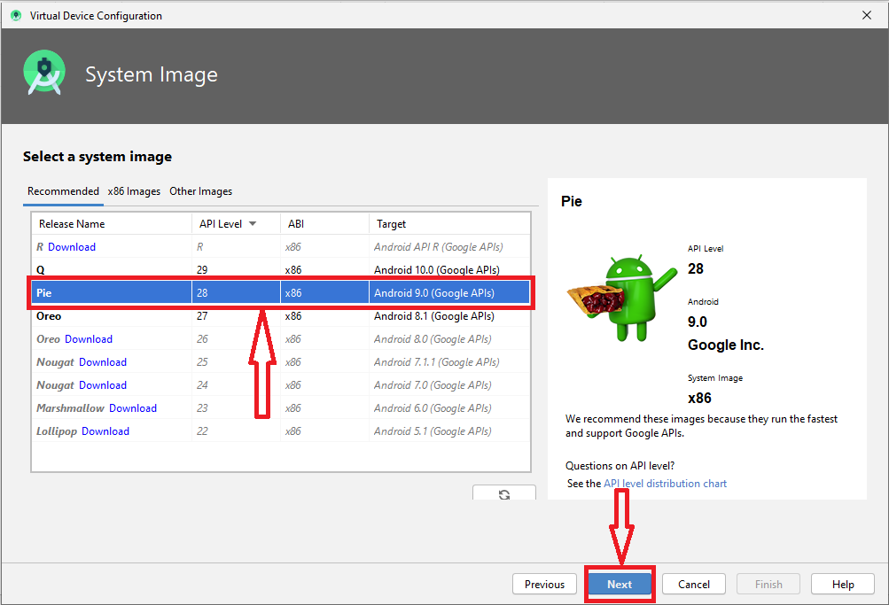

1. Under Emulated Performance, select **Hardware - GLES 2.0**. Verify the AVD configuration is correct, and select **Finish**.

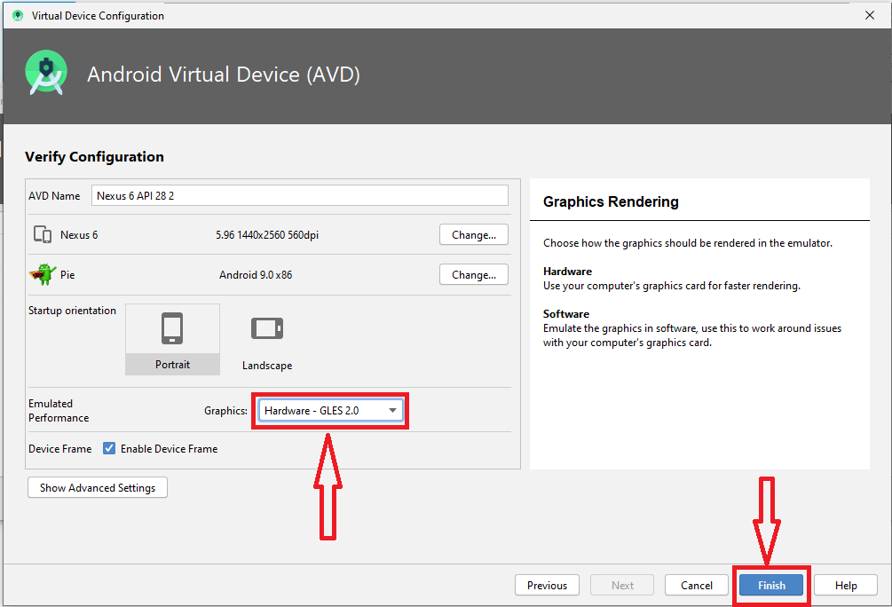

1. In Android Virtual Device Manager, click **Run** from the toolbar.

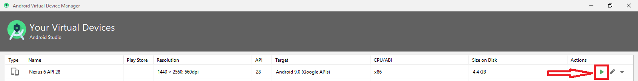

1. The emulator starts up and displays the default canvas for selected OS version and device.

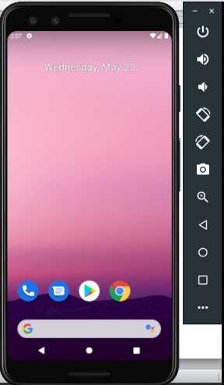

# **Build and Run the Project in the Emulator:**

1. Clone the git repository from [https://github.com/tsiAILAB/Plant-Pathology.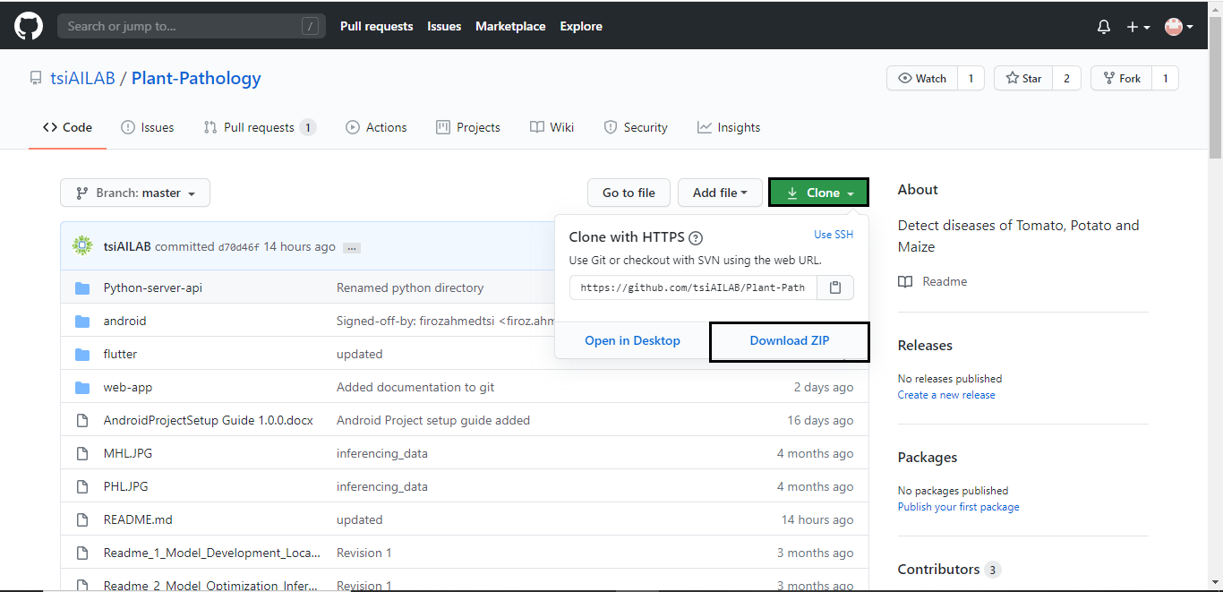](https://github.com/tsiAILAB/Plant-Pathology.)

Please download the zip and extract.

1. Open the project in android studio marked menu.

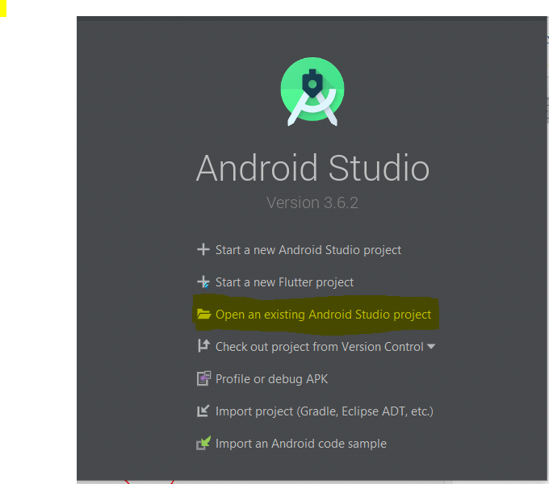

1. Select the project folder which is downloaded from Git Repository. The project should be this location of coned GIT “\plant-pathology\flutter\plantpathologyandroid”
2. Download all dependencies by clicking **Get dependencies**



1. Click (**<no devices>**)-highlighted in below image, and select device/emulator.



1. Click on the **Run icon** to run the project in the device/emulator (shown in the image given below).



# **Build APK**

1. To build apk go to build menu of Android Studio
2. Select “Build Bundle(s)/ APK(s)”
3. Build APK(s)

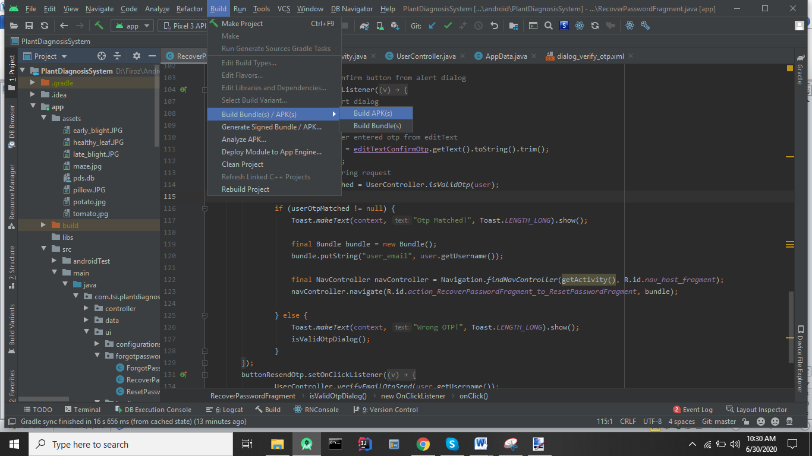

1. An APK will generated in the build folder

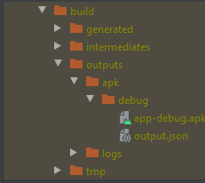

# **Run the own Built App**

* 1. Copy the **app-debug.apk** file to android device.
  2. Select the file to install.

|  |  |
| --- | --- |
| **Installation**  C:\Users\Shahidul Karim\Desktop\Firoz\screenshoots-20200519T133119Z-001\screenshoots\Screenshot_2020-05-19-16-05-38-052_com.google.android.packageinstaller.png  Tap to INSTALL to get the app installed in your device. | **Installation**  C:\Users\Shahidul Karim\Desktop\Firoz\screenshoots-20200519T133119Z-001\screenshoots\Screenshot_2020-05-19-16-05-54-838_com.google.android.packageinstaller.png  After getting the Installation confirmation, tap on OPEN button to start the app |